# Renewable Energy and Backup Generators: Can They Work Together?



Featured image

Alt tag: Solar panel on the roof of a house

Energy is essential in your daily life, but power outages can disrupt everything from comfort to productivity. To combat this, many people turn to renewable energy and backup generators. Renewable energy, like solar or wind power, offers a cleaner, sustainable way to produce electricity but can falter during poor weather or at night. [Backup generators](https://qualitytx.com/generator/), on the other hand, provide reliable power on demand, filling in gaps when renewables fall short. The big question is whether these two systems can work together to create a reliable, sustainable energy solution. Let’s explore how combining these technologies could perfectly balance environmental responsibility and dependable power.

## How Renewable Energy Works

Renewable energy comes from natural replenishment sources, such as sunlight, wind, and water. These abundant and free sources make them a popular option for producing electricity. Solar panels capture sunlight and convert it into usable energy, wind turbines harness air movement to generate power, and hydropower systems use flowing water for electricity. One major benefit of renewable energy is its minimal environmental impact, as it produces little to no harmful emissions compared to fossil fuels. However, renewable energy is not always reliable since solar panels depend on sunlight, and wind turbines require wind. This inconsistency makes renewable energy most effective when paired with systems that can store or supplement power during downtime, offering a promising path toward cleaner energy solutions.



Caption: Renewable energy uses natural resources like sun, wind, and water to create sustainable power.

Alt tag: Large white wind turbine

## Preparing for a Move to a Greener Future

Planning a move is an exciting opportunity to start fresh, especially in places driving renewable energy innovation. With its vast wind farms and rapidly expanding solar power, Texas is a prime example of clean energy shaping the future. Moving to this state, which embraces progress in renewable energy, offers the chance to join a community focused on sustainability. If you're relocating here, it’s important to [have quality moving supplies](https://proallianceservices.com/moving-supplies/) to ensure your belongings arrive safely. With sturdy packing materials and the right preparation, you’ll be ready to settle in and embrace everything your new home has to offer.

## Backup Generators: A Reliable Standby

Backup generators provide power during outages when your main energy source is unavailable. These systems run on fuels like diesel, natural gas, or propane, making them reliable when storms, grid failures, or other issues disrupt electricity. Generators commonly used in homes, businesses, and critical facilities like hospitals ensure that power is available when needed. They work by converting fuel into electricity, which powers essential appliances, lights, and devices. These generators start quickly, minimizing downtime during an outage. However, traditional generators come with some downsides, including noise, high fuel costs, and environmental concerns due to emissions. Despite these issues, backup generators remain a trusted solution for maintaining power in emergencies.

## Operational Differences Between Renewable Energy and Backup Generators

Combining renewable energy and backup generators presents some challenges due to their differing operational characteristics. Renewable energy systems, like solar and wind, are dependent on natural conditions, meaning they aren’t always reliable. Solar panels don’t produce energy at night, and wind turbines require wind to generate power. Backup generators, while dependable, run on fuel and only activate when needed, adding an extra layer of complexity when integrating with renewable sources. Additionally, these systems must be carefully synchronized to work seamlessly together, requiring specialized equipment like inverters and automatic transfer switches. The challenge lies in balancing the fluctuating output of renewables with the steady backup power from generators while minimizing fuel use and maintaining efficiency.

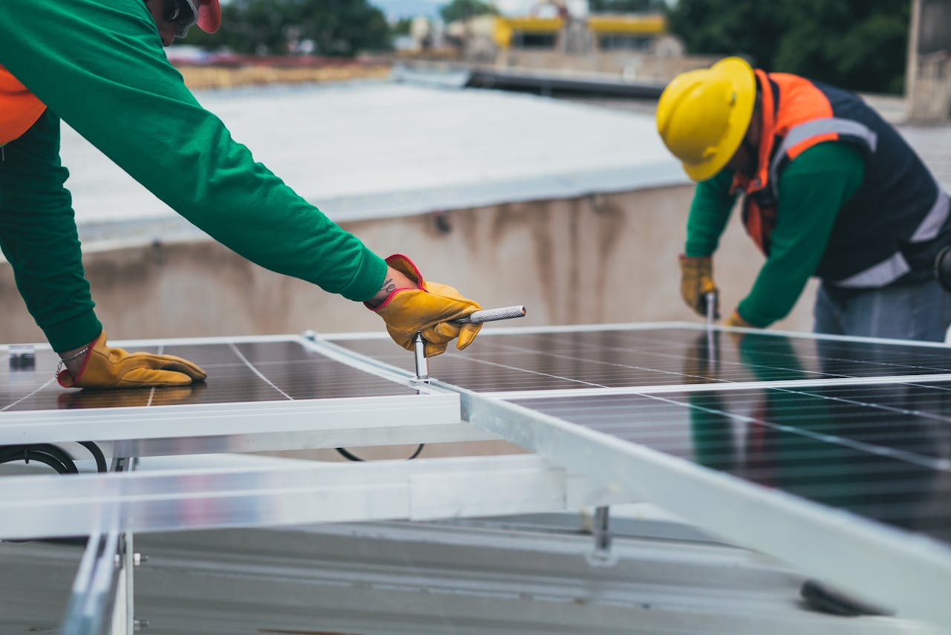

Caption: Integrating renewable energy and backup generators can be a challenge.

Alt tag: Professionals installing solar panels

## Solutions for Seamless Integration

Several solutions can be implemented to make renewable energy and backup generators work together smoothly. Hybrid systems [combine solar panels with batteries](https://qualitytx.com/solar-panels-in-houston-texas/) to store excess energy for later use, ensuring a steady power supply even when natural conditions aren’t ideal. Automatic transfer switches can be used to switch seamlessly when needed, so there’s no interruption in power. In some setups, smart energy management systems can prioritize the use of renewable energy first, with the generator only kicking in when storage is low or demand is high. These technological advancements make it easier to integrate both systems, reducing fuel consumption and improving overall energy efficiency.

## Benefits of Pairing Renewable Energy with Generators

Pairing renewable energy with backup generators offers several key benefits. First, it helps reduce fuel consumption. When the renewable energy system works, it can power your home or business, reducing the time the generator runs and the fuel it uses. This saves money and lowers your environmental impact by reducing emissions. Second, it provides a more reliable energy supply. Renewable energy systems may not always be able to meet demand, especially during cloudy days or calm weather, but backup generators can fill in the gaps when needed. Third, it creates energy independence, giving you more control over your power source and reducing reliance on the grid. With this combination, you can enjoy both sustainability and reliability in your energy setup.



Caption: Once everything is set up, you’ll have a reliable power source for uninterrupted comfort!

Alt tag: Couple relaxing and watching TV

## Real-World Examples

Many homeowners and businesses are already seeing the benefits of combining renewable energy with backup generators. For example, in remote areas with limited access to the electrical grid, solar panels are paired with diesel generators to provide a reliable power supply. During the day, solar energy powers the home, and at night or during cloudy weather, the generator kicks in. Similarly, some businesses use wind power as their primary energy source, with a backup generator to ensure continuous operations during low-wind periods. The combination reduces fuel costs, lowers carbon emissions, and improves energy reliability in both cases. These real-world setups demonstrate how pairing renewable energy with generators offers a practical, sustainable solution for consistent power.

## Practical Challenges and How to Overcome Them

One challenge when combining renewable energy and backup generators is the initial investment. However, over time, you can save on energy costs and reduce fuel consumption, making the investment worthwhile. Another issue is fuel usage. Generators, particularly traditional models, can be costly to operate and contribute to emissions. A solution is to consider more eco-friendly alternatives like propane or natural gas or even look into hybrid generators that run on a mix of fuels. Regular maintenance is also important to keep both systems functioning properly over the long term. By working with a company that installs, maintains, and repairs these systems, you can [keep them in top shape](https://qualitytx.com/), preventing costly repairs and improving efficiency. This makes your energy setup reliable, cost-effective, and environmentally friendly.

## Final Thoughts

In conclusion, combining renewable energy and backup generators can provide a reliable, sustainable energy solution. While each system has its limitations, pairing them together creates a balanced approach to power that reduces fuel consumption, lowers emissions, and ensures you always have access to energy when needed. You can maximize efficiency and minimize downtime by integrating technologies like battery storage and automatic transfer switches. Despite the upfront costs and maintenance requirements, the long-term benefits make this combination appealing to homeowners and businesses alike. Embracing both could be the key to a more resilient and eco-friendly energy future.

Meta Description: Learn how renewable energy and backup generators can work together to provide reliable, sustainable power for your home or business.

KW: Renewable Energy and Backup Generators

Photos used:

<https://www.pexels.com/photo/a-house-with-solar-panel-on-the-roof-12243093/>

<https://www.pexels.com/photo/white-windmill-414837/>

<https://www.pexels.com/photo/selective-focus-of-installing-on-solar-panels-8853499/>

<https://www.pexels.com/photo/couple-love-sitting-evening-4009409/>